AIM: Design TCP iterative Client and server application to reverse the given input sentence.

DECRIPTION:

Socket function:

#include <sys/socket.h>
int socket int family, int type, int protocol);

The family specifies the protocol family

Family Description

AF_INET IPV4 protocol AF_INET6 IPV6 protocol AF_LOCAL unix domain protocol AF_ROUTE routing sockets AF_KEY key socket

Type Description

SOCK_STREAM Stream description SOCK_DGRAM Datagram socket SOCK_RAW Raw socket

The protocol argument to the socket function is set to zero except for raw sockets.

Connect function: The connect function is used by a TCP client to establish a connection with a TCP server.
int connect(int sockfd, const struct sockaddr *servaddr, socklen_t addrlen);

Bind function: The bind function assigns a local protocol address to a socket.
int bind(int sockfd, const struct sockaddr *myaddr, s ocklen_t addrlen);

Bzero: It sets the specified number of bytes to 0(zero) in the destination. We often use this function to initialize a socket address structure to 0(zero).
#include<strings.h>
void bzer(void *dest,size_t nbytes);

Memset: It sets the specified number of bytes to the value c in the destination.

#include<string.h>
void *memset(void *dest, int c, size_t len);

Close function: The normal UNIX close function is also used to close a socket and terminate a TCP

connection.

#include<unistd.h>

int close(int sockfd);
Return 0 if ok, -1 on error.

Listen function: The second argument to this function specifies the maximum number of connection that the kernel should queue for this socket.
int listen(int sockfd, int backlog);

Accept function: The cliaddr and addrlen argument are used to ret urn the protocol address of the connected peer processes (client)

int accept(int sockfd, struct sockaddr *cliaaddr, socklen_t *addrlen);

IPv4 Socket Address Structure:

An IPv4 socket address structure, commonly called an “ Internet socket address structure, “ is named sockaddr_in and defined by including the <netinet/in.h> header.

struct in_addr
{
in_addr_t s_addr; /* network byte ordered */
};
struct sockaddr_in
{
uint8_t sin_len; /* length of structure(16) */
sa_family_t sin_family; /* AF_INET */
in_port_t sin_port; /* 16-bit TCP or UDP port number*/
/* network byte ordered */
struct in_addr sin_addr; /* 32-bit IPv4 address */
/*newtork byte ordered */
char sin_zero[8]; /* unused */
};
Address Conversion functions

#include<netinet/in.h>
Uint16_t | htons( uint16_t | host16bitvalue);
Uint32_t | htonl( uint32_t | host32bitvalue);
Uint16_t | ntohs( uint16_t | net16bitvalue);
Uint32_t | ntohl( uint32_t | net32bitvalue);

Socket functions for elementary TCP client/server

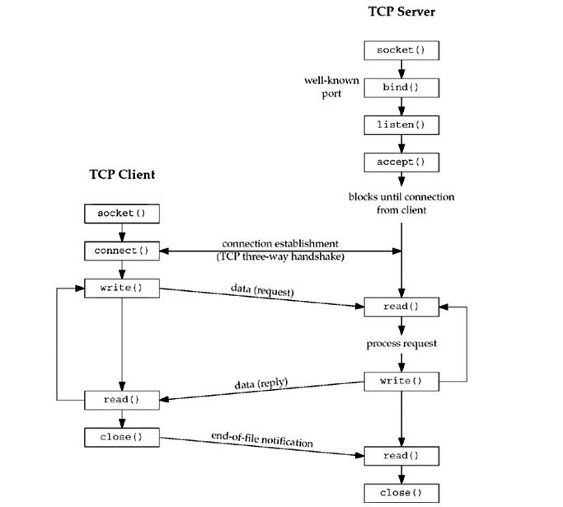

Pseudo code:

START

END

Client sends message to server using sent functions.

Server receives all the messages, server ignores all the consonants in the message. All the vowels in the message are converted into upper case.
Server returns the entire message to clients (with toggled vowel cases).

For example: "This is a test and sample message." to server will be sent back to client as
"ThIs Is A tEst And sAmplE mEssAgE."

When client closes the connection server should close the communication with that client
(socket). And once again wait for new clients to connect. Server program never exits.

Using fork function rewrite the programs, such that this server can handle multiple client connections at one time. To test this you need to run simultaneously multiple copies of client executions. Please log on server machine number of clients it is handled at this time.

PROGRAM

CLIENTPROGRAM

#include<string.h>
#include<stdio.h>
#include<stdlib.h>
#include<unistd.h>
#include<sys/socket.h>
#include<netinet/in.h>
#include<sys/types.h>
#define MAXLINE 20
#define SERV_PORT 5777 main(int argc,char *argv)
{
char sendline[MAXLINE],revline[MAXLINE];
int sockfd;
struct sockaddr_in servaddr;

sockfd=socket(AF_INET,SOCK_STREAM,0); bzero(&servaddr,sizeof(servaddr)); servaddr.sin_family=AF_INET; servaddr.sin_port=ntohs(SERV_PORT);
connect(sockfd,(struct sockaddr*)&servaddr,sizeof(servaddr));
printf("\n enter the data to be send");

while(fgets(sendline,MAXLINE,stdin)!=NULL)
{

}
exit(0);
}
write(sockfd,sendline,strlen(sendline)); printf("\n line send"); read(sockfd,revline,MAXLINE);
printf("\n reverse of the given sentence is : %s",revline);
printf("\n");

SERVER PROGRAM

#include<string.h>
#include<stdio.h>
#include<stdlib.h>
#include<unistd.h>
#include<sys/socket.h>
#include<netinet/in.h>
#include<sys/types.h>
#define MAXLINE 20
#define SERV_PORT 5777 main(int argc,char *argv)
{
int i,j;
ssize_t n;
char line[MAXLINE],revline[MAXLINE];
int listenfd,connfd,clilen;
struct sockaddr_in servaddr,cliaddr;

listenfd=socket(AF_INET,SOCK_STREAM,0); bzero(&servaddr,sizeof(servaddr)); servaddr.sin_family=AF_INET; servaddr.sin_port=htons(SERV_PORT);
bind(listenfd,(struct sockaddr*)&servaddr,sizeof(servaddr));
listen(listenfd,1);

for( ; ; )
{
clilen=sizeof(cliaddr);
connfd=accept(listenfd,(struct sockaddr*)&cliaddr,&clilen);
printf("connect to client");
while(1)
{
if((n=read(connfd,line,MAXLINE))==0)
break;

line[n-1]='\0';
j=0;

for(i=n-2;i>=0;i--)
revline[j++]=line[i]; revline[j]='\0'; write(connfd,revline,n);
}
}
}

OUTPUT

